Shutil Module in Python
Shutil is a Python module that provides a higher level interface for working with file and directories. The name "shutil" is short for shell utility. It provides a convenient and efficient way to automate tasks that are commonly performed on files and directories. In this repl, we'll take a closer look at the shutil module and its various functions and how they can be used in Python.
Importing shutil
The syntax for importing the shutil module is as follows:
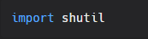
Functions
The following are some of the most commonly used functions in the shutil module:
- shutil.copy(src, dst): This function copies the file located at src to a new location specified by dst. If the destination location already exists, the original file will be overwritten.
- shutil.copy2(src, dst): This function is similar to shutil.copy, but it also preserves more metadata about the original file, such as the timestamp.
- shutil.copytree(src, dst): This function recursively copies the directory located at src to a new location specified by dst. If the destination location already exists, the original directory will be merged with it.
- shutil.move(src, dst): This function moves the file located at src to a new location specified by dst. This function is equivalent to renaming a file in most cases.
- shutil.rmtree(path): This function recursively deletes the directory located at path, along with all of its contents. This function is similar to using the rm -rf command in a shell.

Examples
Here are some examples of how you can use the shutil module in your Python code:
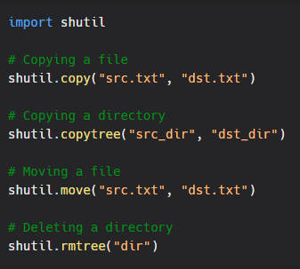
As you can see, the shutil module provides a simple and efficient way to perform common file and directory-related tasks in Python. Whether you need to copy, move, delete, or preserve metadata about files and directories, the shutil module has you covered.
In conclusion, the shutil module is a powerful tool for automating file and directory-related tasks in Python. Whether you are a beginner or an experienced Python developer, the shutil module is an essential tool to have in your toolbox.

